Train employees on secure remote work practices

Steps do use FortiClient VPN to connect local network:

1-Install FortiClient application (do by IT Team)

2-After installation configure VPN as below screenshot, in username you write your username that will share with you by IT Team, then click save

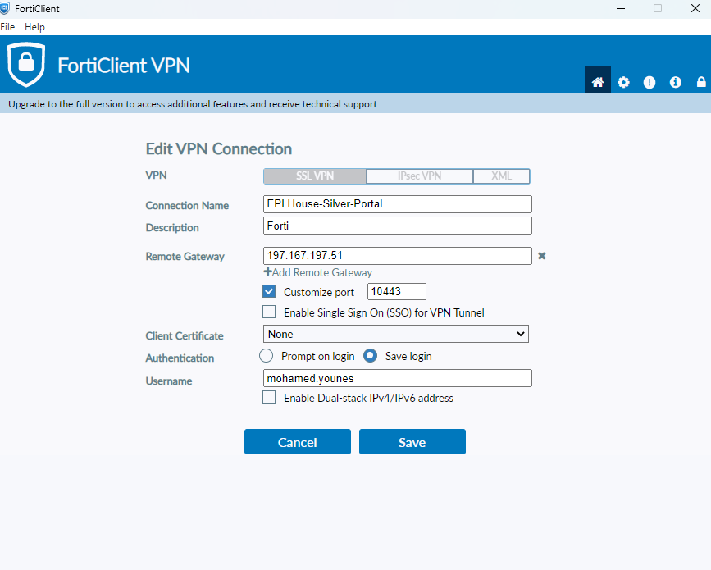

3-Write your password that will be share with you by IT Team, click on save password then click connect

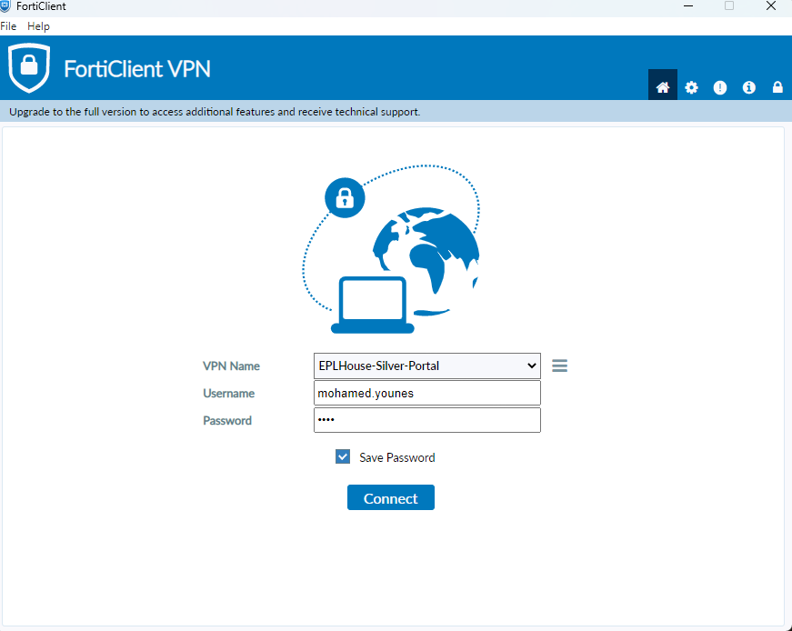

4-Within connection at 40 % will appear trust message, click yes then VPN will be up and then can connect to local network that you have access on it

